# 1.Registration Page

Register page for all users:

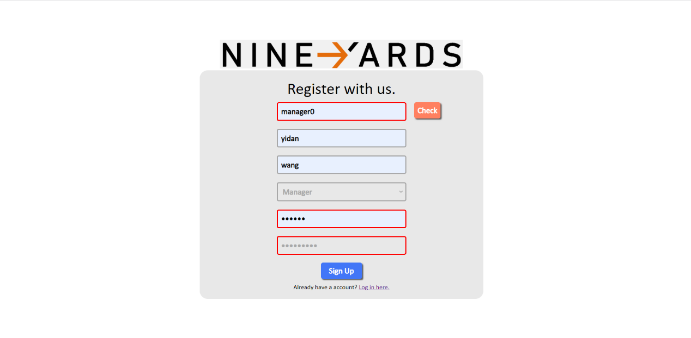Figure 1. When the account is already occupied, a red frame is displayed

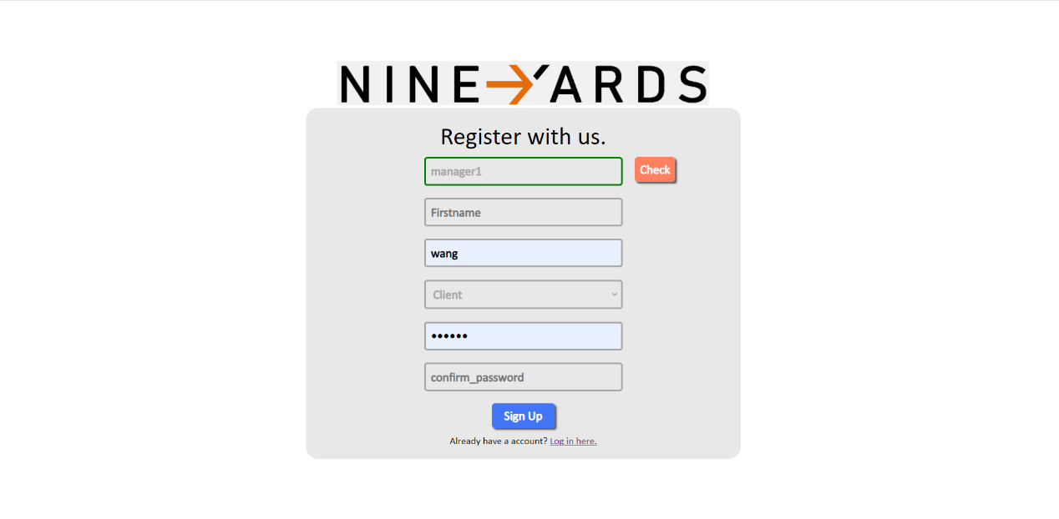

Figure 2. When the account can be registered, a green frame is displayed

Users can enter their information details on the registration page. Click on check button to check if the account is available. If the account is already registered, a red box will be displayed to remind the user. If the account is unregistered and still available, a green box will be displayed to alert the user. If the password entered twice is not the same, a red box will be displayed to alert the user. It is important to note that there are three different identities - client, team member and manager - and that users with different identities have different privileges. Users will need to choose their own identity and can only choose one of them. If the user already has an account, clicking on the link below will redirect them to the login page. When all the information has been entered properly, click signup to jump to the login page.

# 2.Login Page

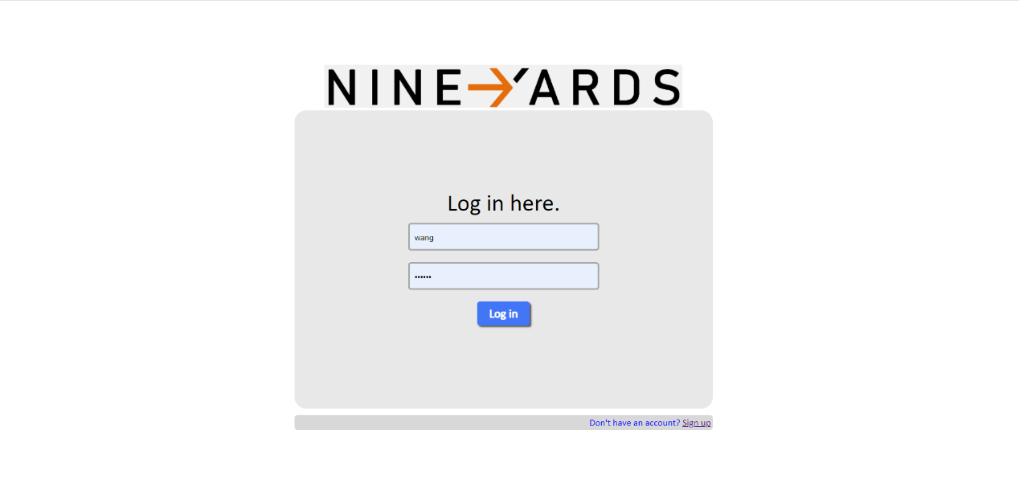Login page for all users:

Figure 3. After successful registration, all users with identities will enter the system from this login interface

If the user does not have a registered account, clicking on the link below will redirect them to the registration page. If the user has a registered account, they can enter the information they entered on the registration page, including their account and password. Click on log in button and you will be redirected to the main page.

# 3.Homepage

## 3.1 Homepage for manager:

Figure 4. The initial state of the homepage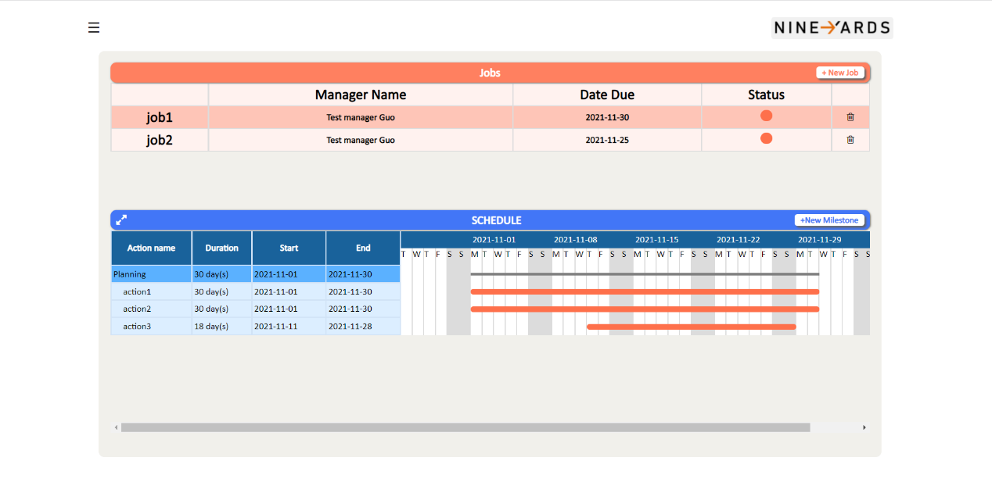

The main page will display the jobs associated with the user, including the job name, manager name, date due and status. When the user selects a job, the schedule below will display the actions within the job, the duration, start time and end time of the actions. On the right side of the Gantt chart different actions are displayed on the calendar.

Figure 5. The new milestone generated by clicking the "+" button will be displayed in a black frame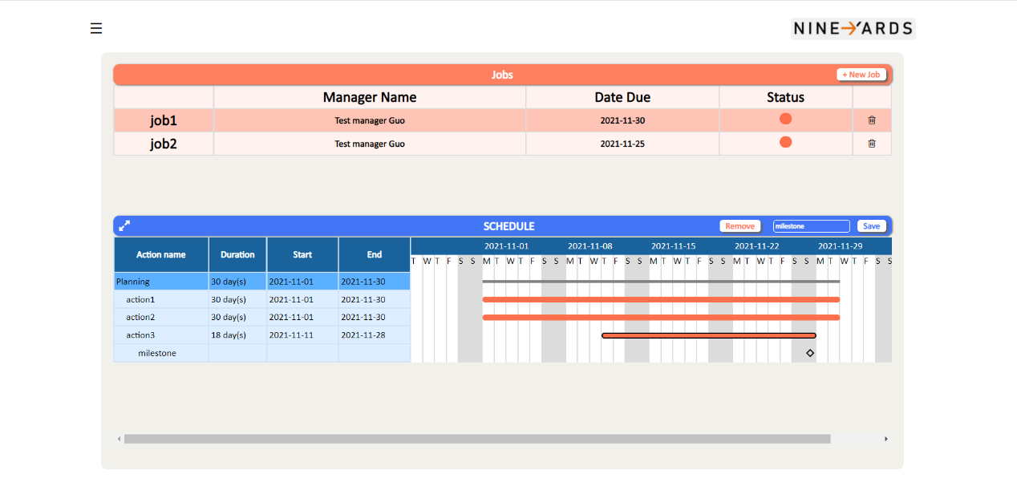

When the user clicks on + new job button, they will be redirected to the new job page. Once the job has been created, the job information will also be displayed on the homepage. Users can delete created jobs by clicking the delete button. Users can click on different actions in the Gantt chart to jump to the edit action page. When the user clicks +new milestone button, a black box will appear around the selected actions. Click save button to save the milestone. Click remove button to remove milestone. After Milestone is saved, a black hollow square will appear below the selected action as the mark of milestone.

## 3.2 Homepage for client and team member:

Figure 6. The functions contained in the homepage under different identities are the same

Clients and team members cannot create new jobs on the home page, and the other functions are the same as managers.

# Dashboard Page

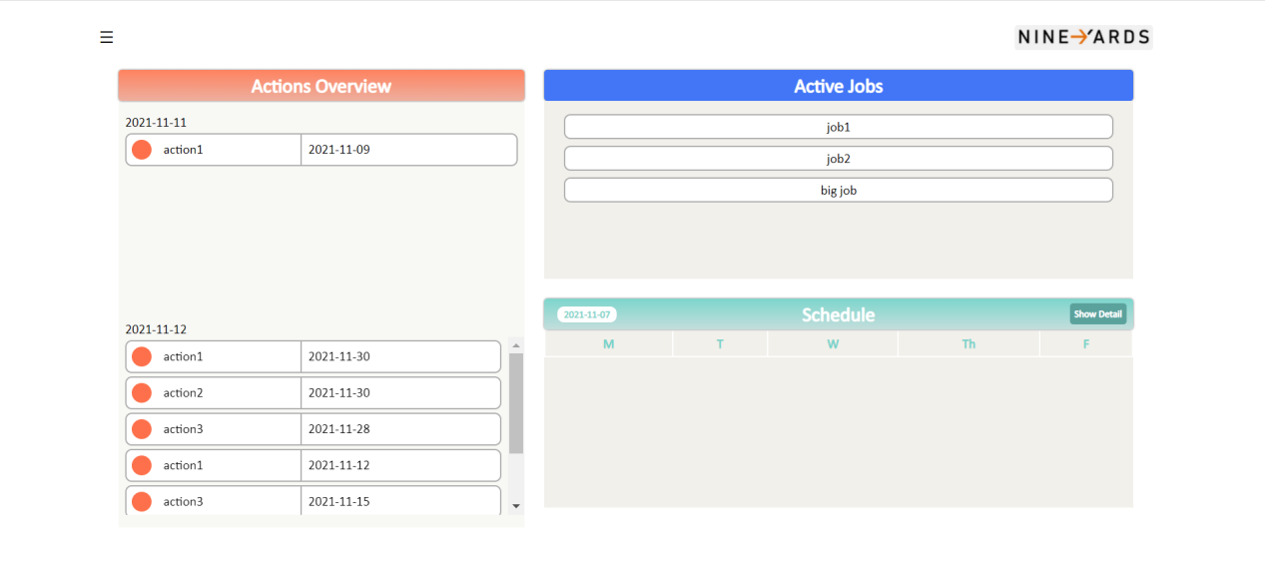

On the Dashboard page, users can see that the actions from the last two days are displayed on the left, and their specific information and schedule are on the right.

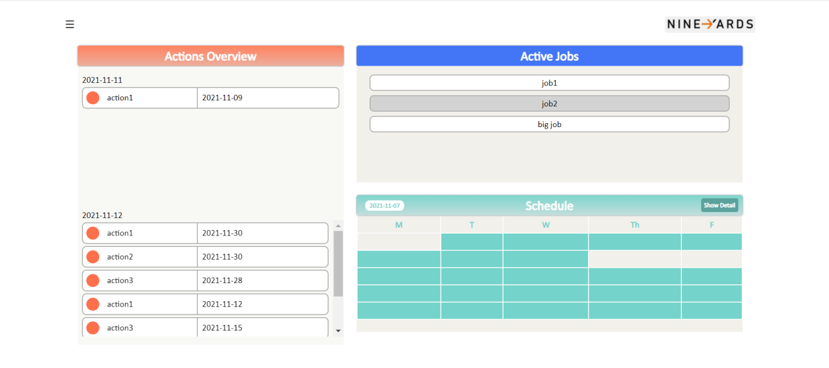

When the user selects one of the jobs in the information bar on the right, the button will change from white to gray, and the corresponding timetable will be displayed at the bottom right.

# Side Navigation Bar

When the user clicks the button in the upper left corner of the page, the quick navigation bar belonging to "Home" and "Dashboard" can be opened, and it will appear on the left side of each page.

## 5.1 Side Navigation Bar for Home Page

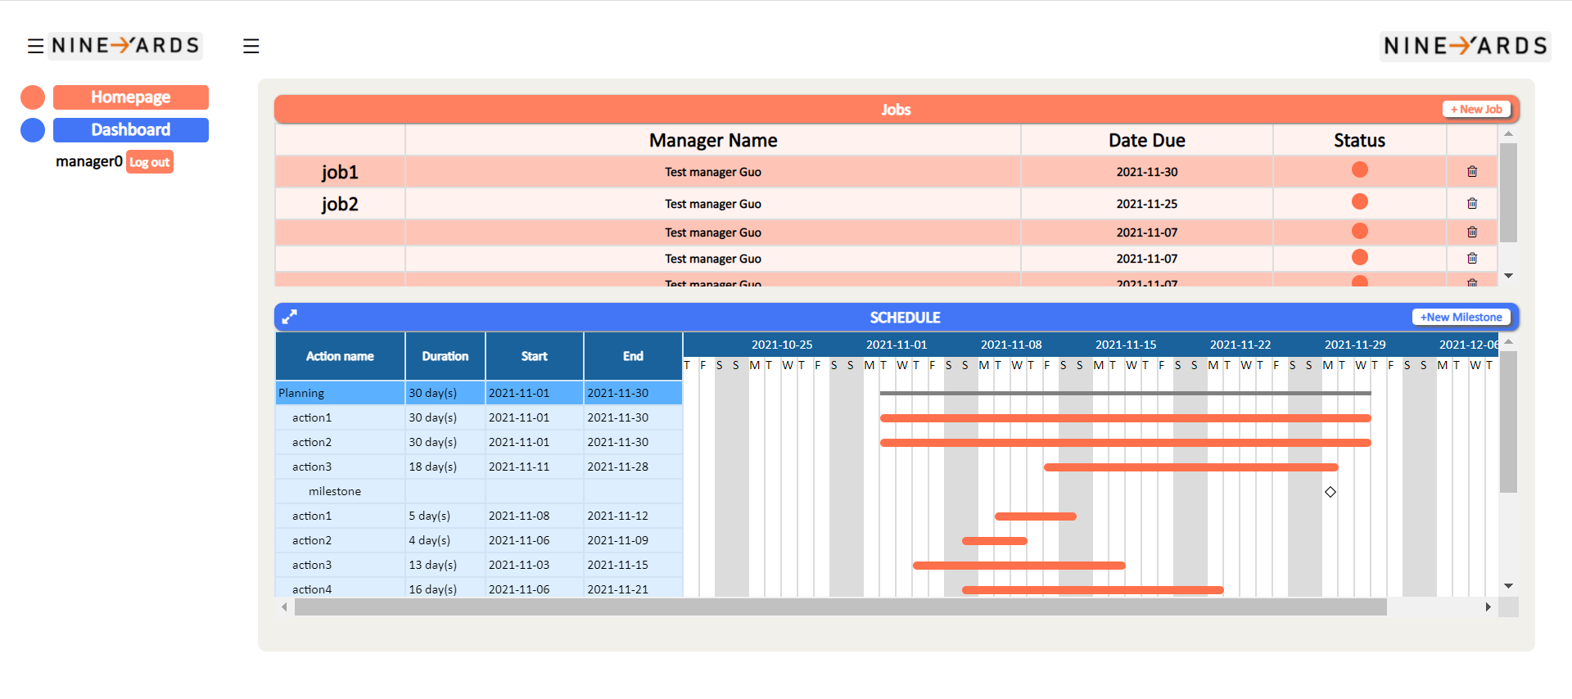

## 5.2 Side Navigation Bar for Dashboard

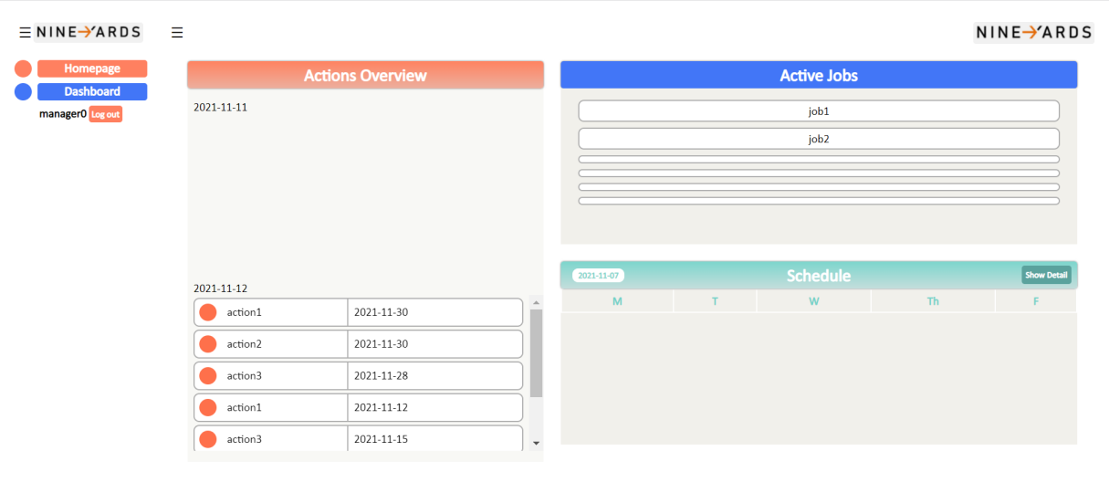

# Job Detail Page

In the Dashboard Page, when the user clicks the show detail button on the timetable at the bottom right, it will jump to this Job Detail page.

## 6.1 Initial state of Job Detail page

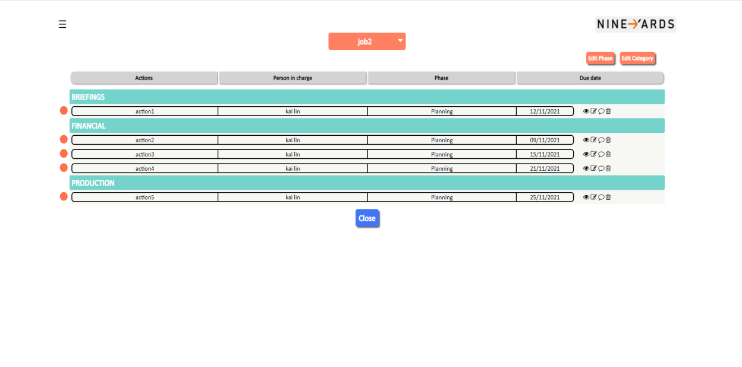

In the default state of "Job Detail", the function of the small icon on the right will be displayed differently according to the identity of the user. Managers have the most permissions, which are "view", "edit", "comment" and "delete" buttons.

## 6.2The user chooses a different job

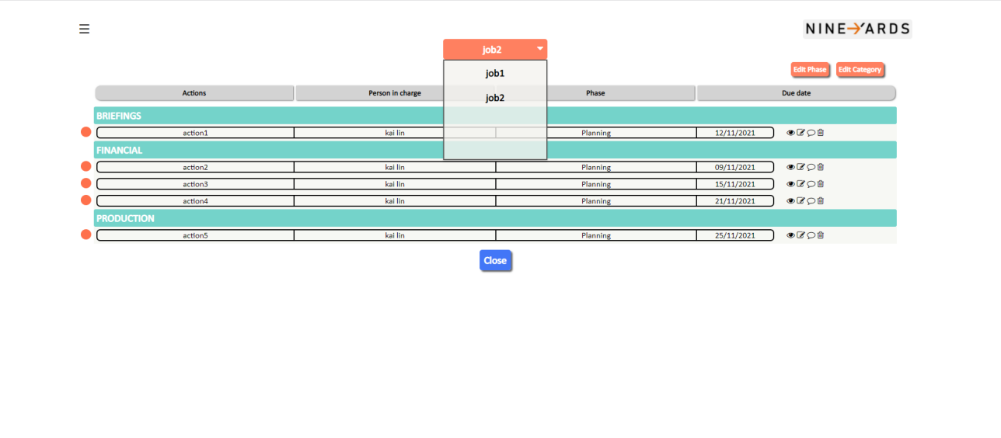

In the title position of the job, the user can select a different job and switch to view the specific information of another job.

## **6.3 Clicked the "Edit Phase" button**

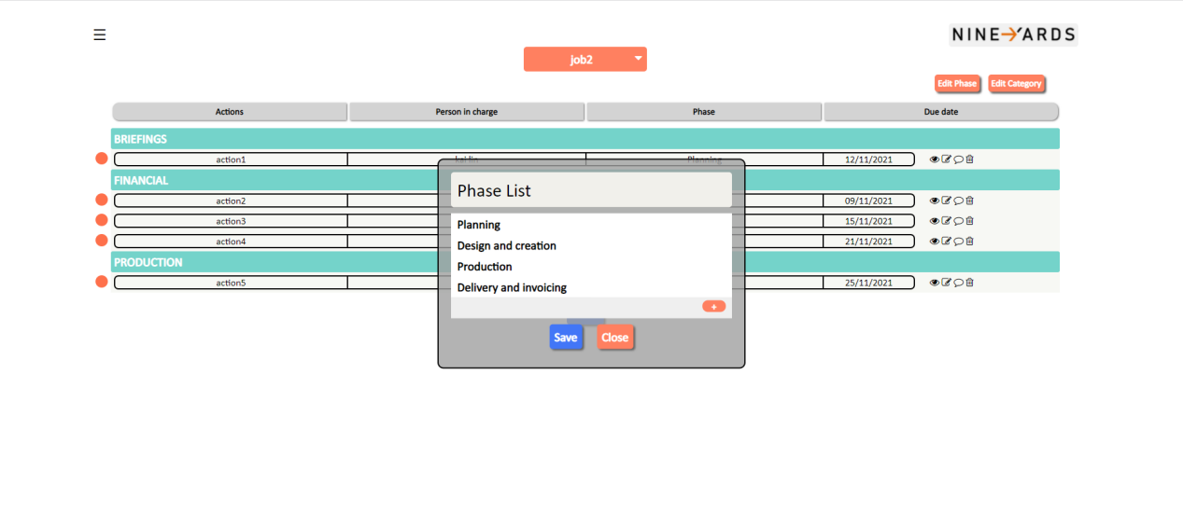

## 6.4 Clicked the "Edit Category" button

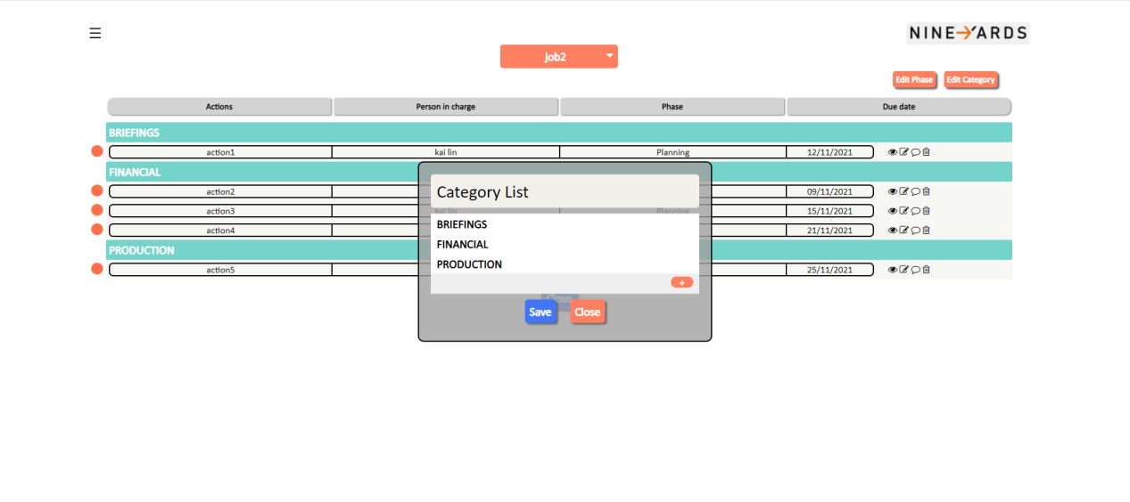

# Action Information Page

Action information page for all users:

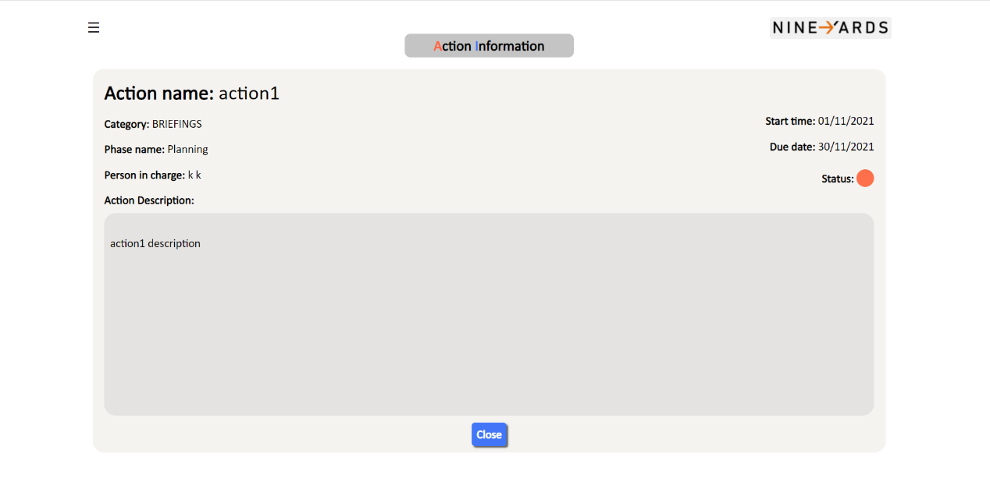

The action information interface will display all relevant information about the action. This information includes action name, category, phase name, person in charge, action description, start time, end time and status. Click close to jump to the job detail interface.

# Job Creation Page

## 8.1 Initial state of Job Creation page

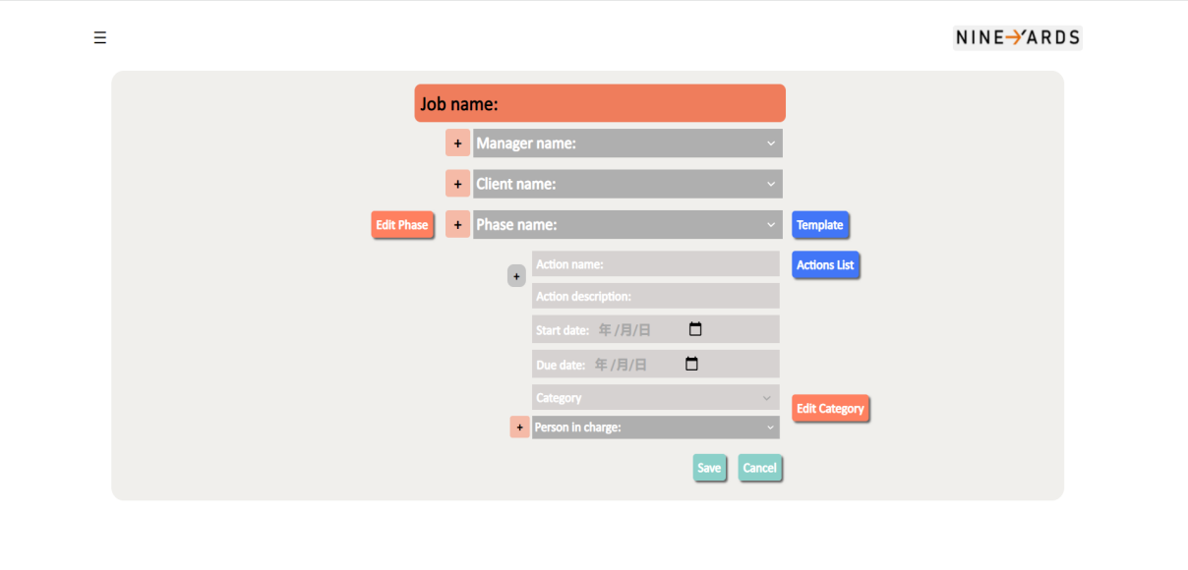

Users can fill in all relevant information on the Job Creation page, including the phase and action attached to a Job. The user clicks on different buttons on the page to realize the jump of the corresponding function.

## 8.2 Clicked the "Edit Phase" button

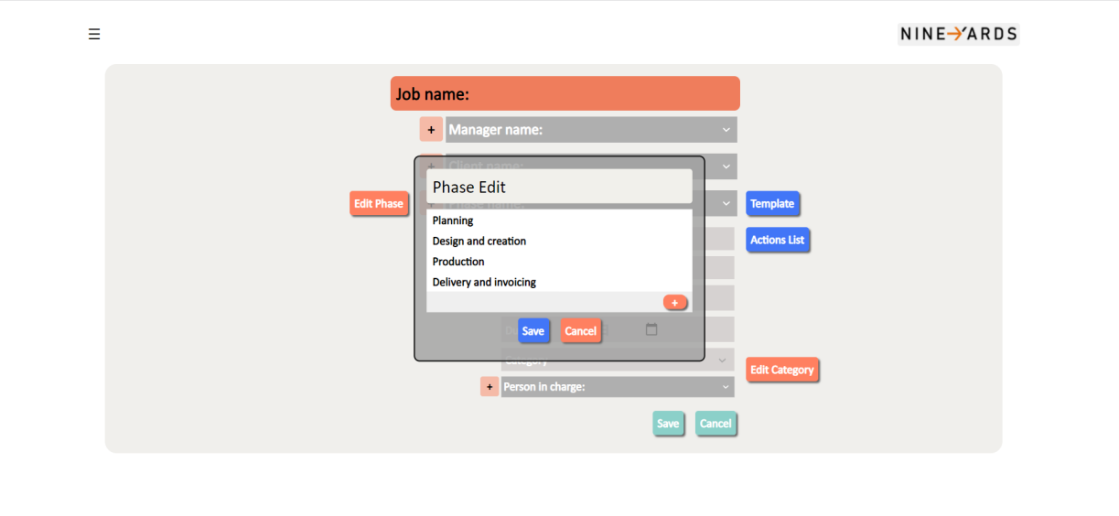

## 8.3 Clicked the "Edit Category" button

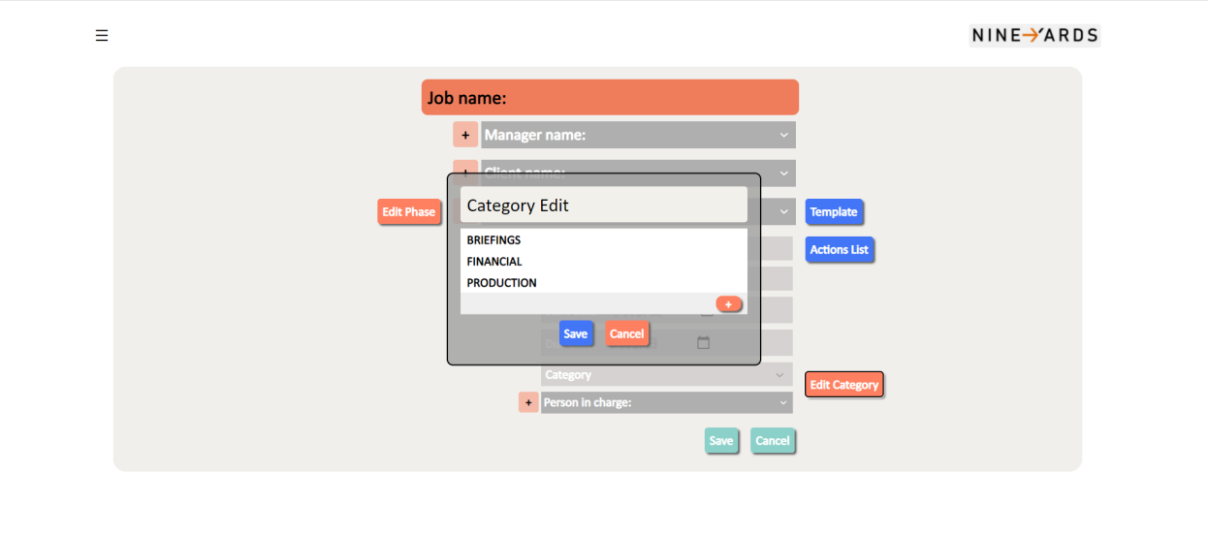

## 8.4 Clicked the "Action List" button

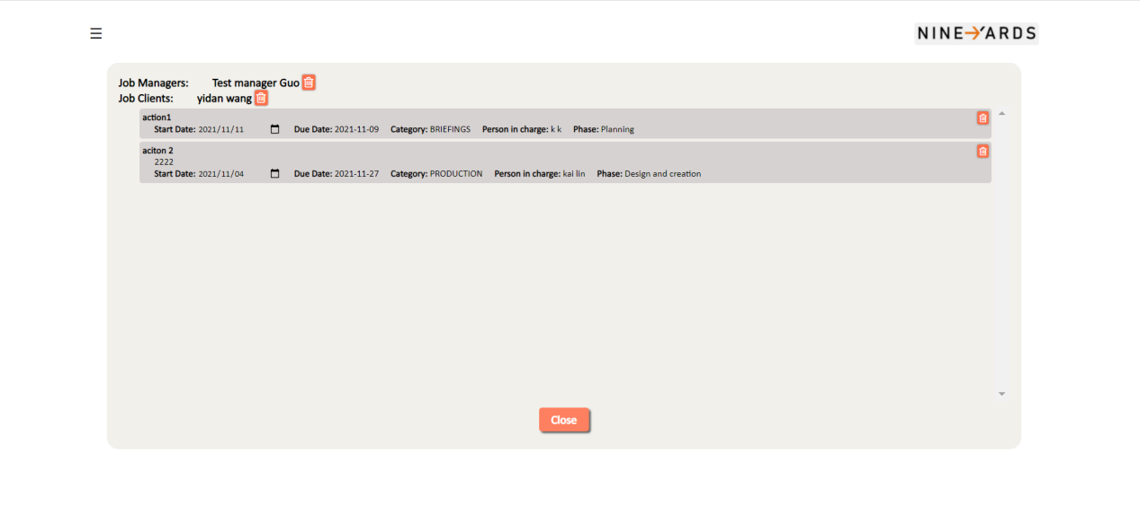

# Phase Template Page

Phase template page for manager:

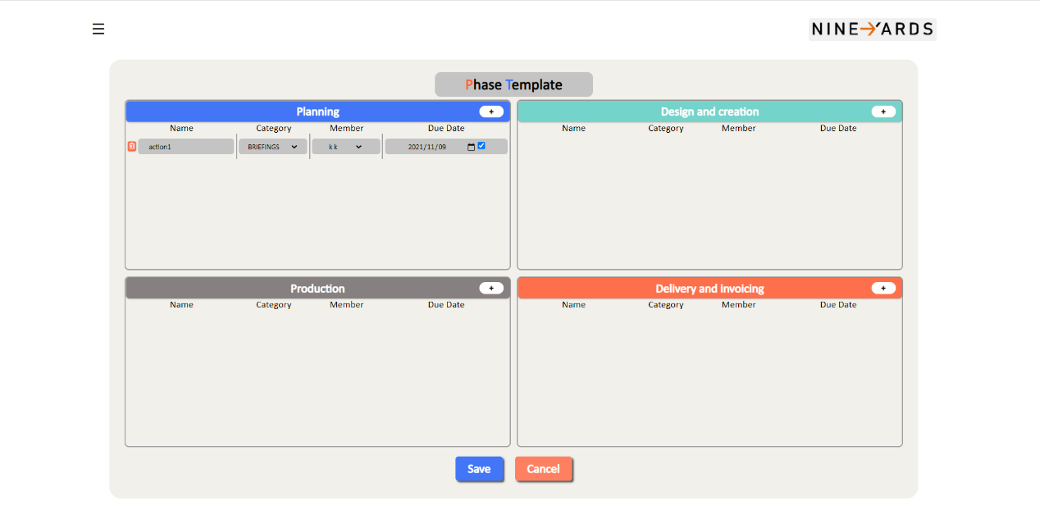

This page displays the templates used for job creation in the different phases. Users can also click on the plus button to create a new template. Once the desired page is selected, the user clicks save button to save the information and jumps back to the create job page.

# Comments Board Page

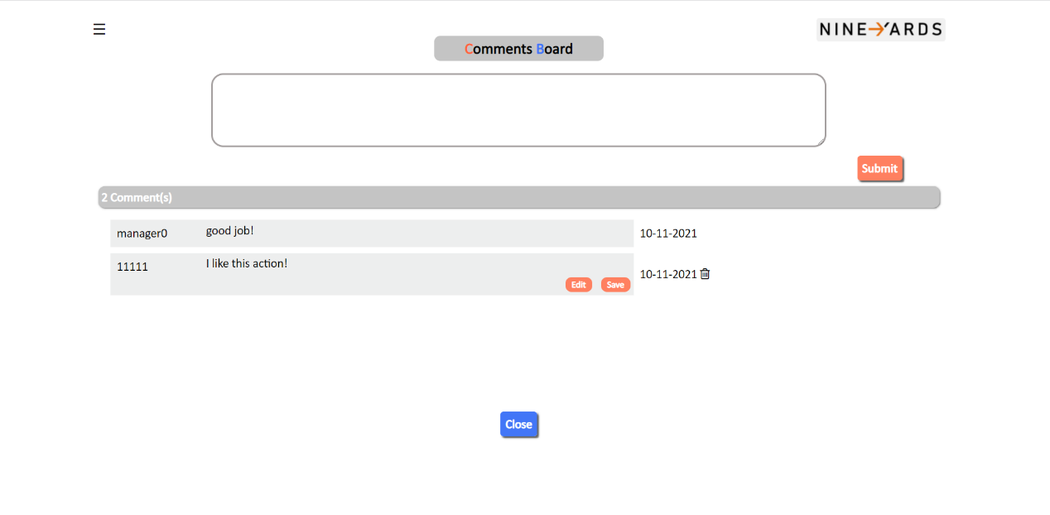Comment board for all users:

The comments board interface can display comments for each action. Users can enter their own comments here and click submit button to save the comments. Users can view the number of the action comments, the content of the comment, the time and the commenter. Click close button to jump to the job detail interface. Users can delete their own comments.